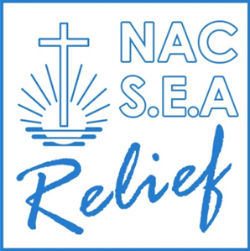

June 28, 2018

To: Management of STAMM International, Inc.
3407 General Lim St.
Brgy. Bangkal,
Makati City.

Re- Relief Operation Ginhawa in Cagayan De-Oro And Lanao Del Norte

Dear Ma’am/Sir,
This is to acknowledge your donation of PhP100,000.00 for above-mentioned relief operation.
You have supported our initiative together with ALPS (Aid Line Philippines -Swiss) and the Swiss Foundation of Island Kids Philippines.
We thank you very much for your generous support and are pleased to submit the closing report and accounting.
A special thank you and appreciation we extend to you also on behalf of all the victims and beneficiaries of your support.
All original accounting documents and official receipts are with ALPS for proper auditing.
We highly value to be your partner for corporate social responsibility and stay at your disposal for further activity refer to our Annual report 2017.
With best wishes for prosperous business and a heartfelt “God Bless”.
Yours Truly,

Genalyn Mosura
Project and Services

NACSEA Relief 2704 Gen. Capinpin St. Bangkal, Makati City. Tel. Number: +63 2 8452052
Email Address: mail@nacsearelief.org http://www.nacsearelief.org/nacsea-relief-fund/

